Descriptive Statistics — Understanding Your Data

🎯 Objective
To summarize and describe the main features of your dataset using central tendency (mean, median, mode) and dispersion (variance, standard deviation, range).
We’ll use your dataset sleep.csv to understand how people sleep differently based on lifestyle and other factors.

1️⃣ Central Tendency
These values help us understand where most of the data lies.
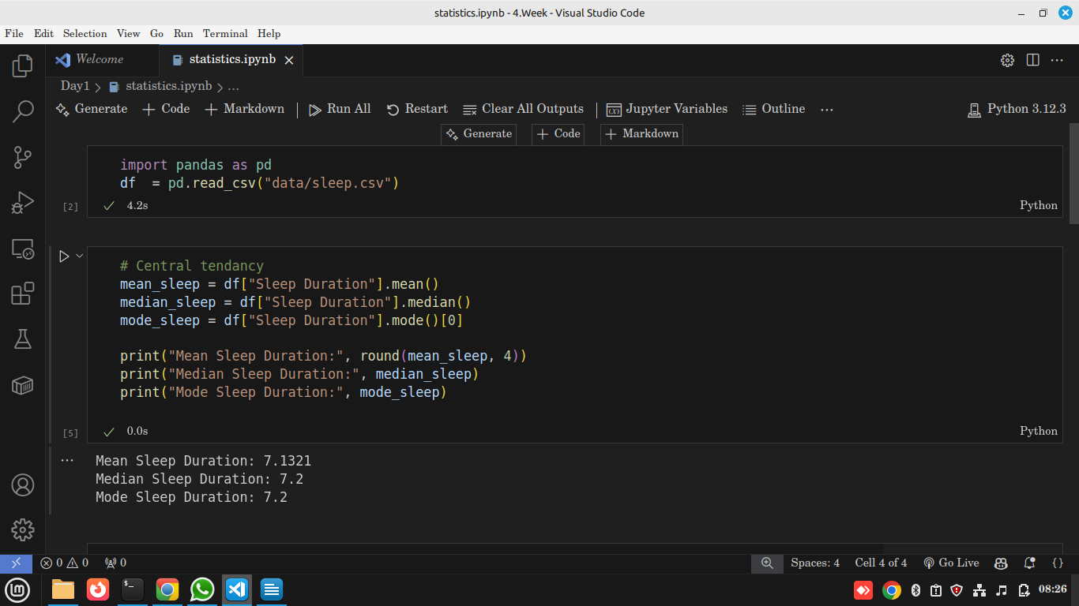

🔍 Explanation
- Mean → The arithmetic average; gives the typical value.
- Median → The middle value when sorted; less affected by outliers.
- Mode → The most frequent value; shows the most common sleep duration.

💡 Insights
- If your dataset has outliers (e.g., someone sleeping only 2 hours), the mean will drop.
- The median still stays stable — it’s more reliable when there are extreme values.
- The mode shows the most common habit — e.g., if mode = 7, most people sleep 7 hours.

🌍 Real-world Use
- In health research, mean and median sleep help define “normal” sleep hours.
- In finance, they summarize typical daily returns.
- In education, mean marks show class performance levels.
- Example: A hospital studying patient recovery times can use mean & median to set treatment expectations.

2️⃣ Dispersion (Spread of Data)
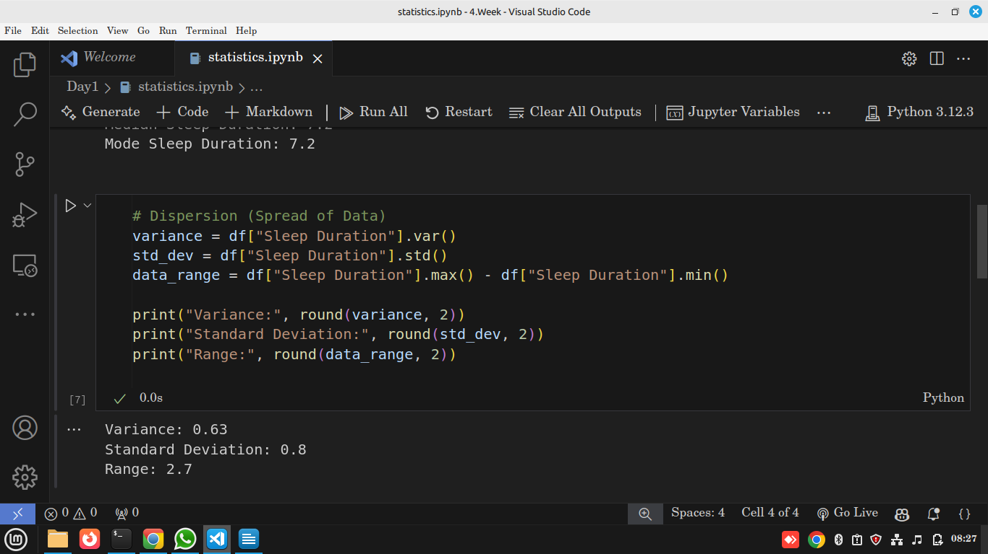

🔍 Explanation
- Variance → Average of squared distances from the mean.
- Standard Deviation (σ) → Typical distance from the mean; tells how consistent or variable the data is.
- Range → Simple difference between highest and lowest value.

💡 Insights
- A small standard deviation means most people sleep similarly (consistent patterns).
- A large std means huge variation — some sleep too much, others too little.

🌍 Real-world Use
- Health: Detect irregular sleep patterns or outliers (e.g., insomnia cases).
- Business: Measure volatility in sales or prices.
- Quality control: Factories use std dev to monitor product consistency.

3️⃣ Full Statistical Summary
df["Sleep Duration"].describe()
Metric | Meaning
count | How many people recorded sleep hours
mean | Average sleep hours
std | Variation in hours
min/max | Shortest and longest sleepers
25%, 50%, 75% | Quartiles showing data spread

💡 Insights
- The IQR (Q3–Q1) shows where the middle 50% of the population lies.
- In your dataset, if Q1 = 6.1 and Q3 = 7.8, then most people sleep between 6–8 hours.

🌍 Real-world Use
- Hospitals or fitness apps (like Fitbit) use quartiles to create “normal sleep range” recommendations.
- Businesses can apply .describe() to customer spending data to understand common patterns.

4️⃣ Visualizing the Distribution
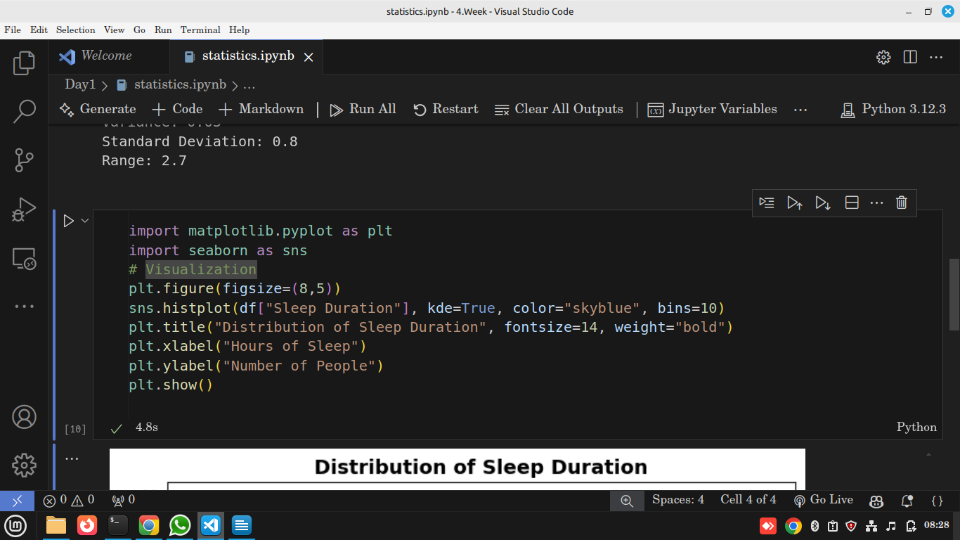

Output
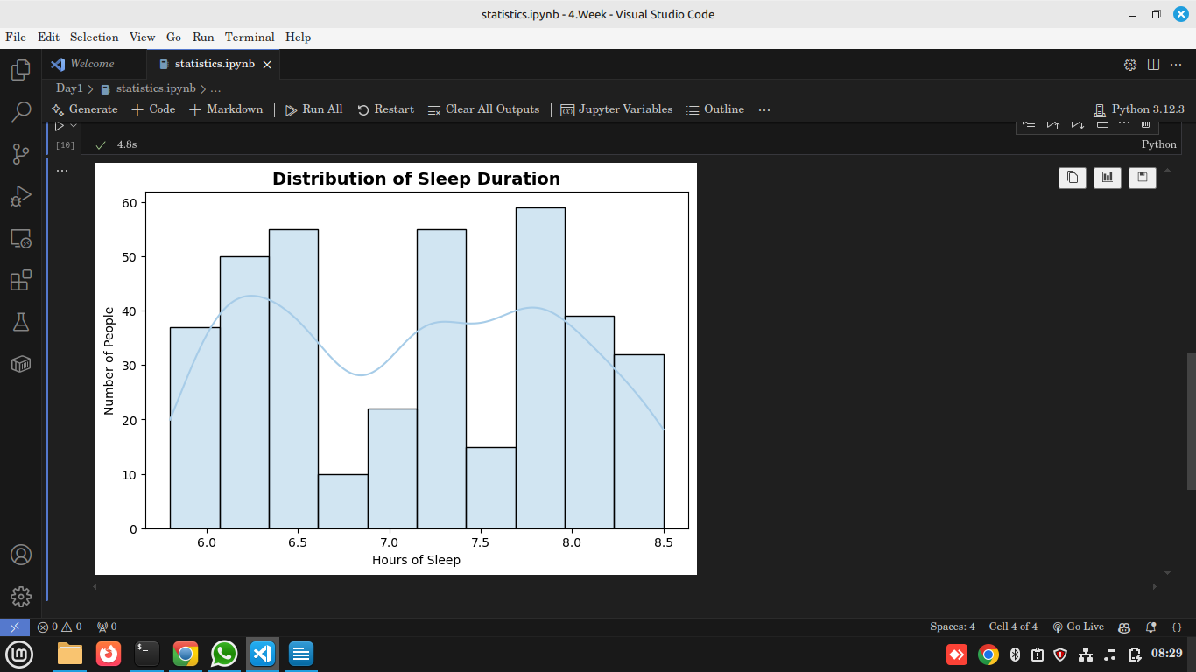

🔍 Explanation
- Histogram → Shows how frequently each sleep duration occurs.
- KDE (Kernel Density Estimate) → Smooth curve showing data density.

💡 Insights
- The KDE peak tells the most common sleep hours — around 7–8 hours.
- Long tails on either side mean a few people sleep unusually less or more.

🌍 Real-world Use
- In data science, histograms help check data normality before modeling.
- Marketing analysts use them to find common purchase frequencies or price points.
- Healthcare can detect sleep issues by spotting unusual sleep hour patterns.

✅ Summary
Concept | Meaning | Python | Real-world Use
Mean | Average | .mean() | Average customer spend, average sleep hours
Median | Middle value | .median() | House price or income where 50% lie below
Mode | Most frequent | .mode() | Common product purchased
Variance | Spread | .var() | Financial volatility
Std Dev | Typical deviation | .std() | Performance consistency
Range | Max–Min | .max() - .min() | Temperature differences
Describe | Summary stats | .describe() | Quick dataset overview

🧩 Assignment
- Compute mean, median, variance, and std for:
  - "Stress Level"
  - "Quality of Sleep"
  - "Physical Activity Level"
- Plot a histogram for "Stress Level" with KDE.
- Write two insights per graph:
  - What pattern do you see?
  - What could it mean in real life?

